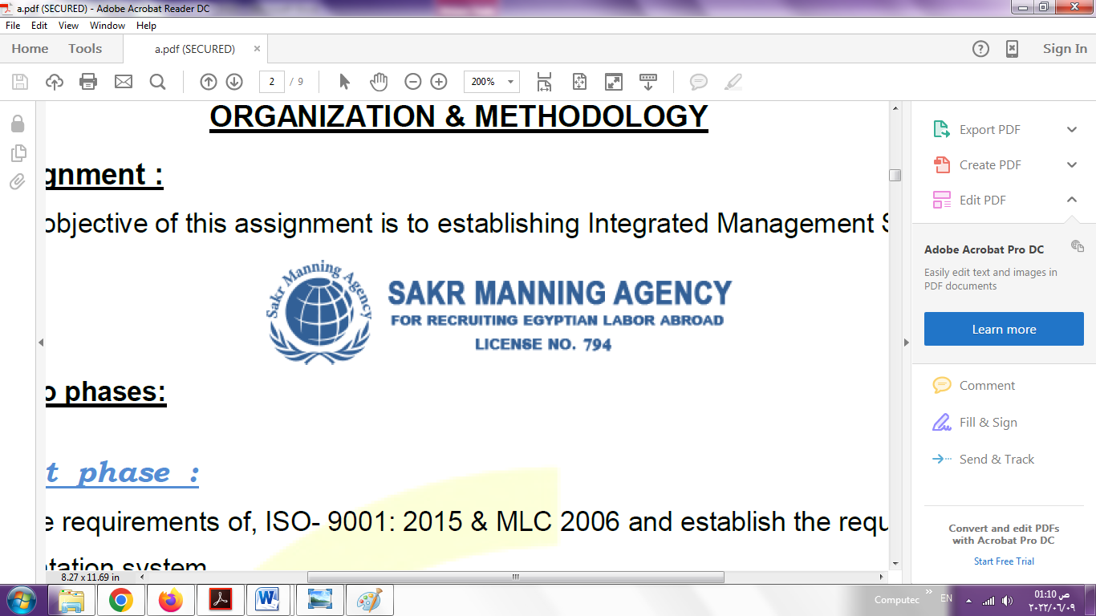 | SAKR MANNING AGENCY  FOR RECRUITING EGYPTIAN LABOR ABROAD | Issue Date | 15.05.2022
 |  | Revision Date | 19.07.2022
 | Crewing Management Manual  Seafarer Employment Application | Revision | 1.1
 |  | Page | 3

Application For Position as | 4th ENGINEER
Register Code. | EO-3.049
Other Position (If Any) | 3rd ENGINEER
Register Date | 07 / 02 / 2023
Last up Date Data
Expected Salary

1. PERSONAL DETAILS
Full Name |  | OSAMA MAHMOUD BAKR ABOU-ZIED
Date Of Birth |  | 14 / 04 / 1972 |  |  |  |  |  |  | Place Of Birth |  |  |  |  |  |  |  | ALEXANDRIA
Nationality |  | EGYPTION |  |  |  |  |  |  | Marital Status |  |  |  |  |  |  |  | Single ☐ |  |  |  |  |  |  |  | Married /
Height (Cm) |  | 173 |  |  |  |  |  |  | Overall Size |  |  |  |  |  |  |  | XXL |  |  |  |  | Shirt Size
Weight (Kg) |  | 85 |  |  |  |  |  |  | Trouser Size |  |  |  |  |  |  |  |  |  |  |  |  | Shoes Size |  |  |  |  |  | 43
2. EDUCATION
College / School |  | Arab ACADEMY
Marline Test |  | Issued Date |  |  |  |  | Result % |  |  |  | Issued By (Authority) |  |  |  |  |  |  |  |  |  | Issued At
English Language |  | Fluent ☐ |  |  |  |  |  | Good / |  |  |  |  | Average ☐ |  |  |  |  |  |  |  | Poor ☐
Arabic……… Language  ( ) |  | Fluent / |  |  |  |  |  | Good ☐ |  |  |  |  | Average ☐ |  |  |  |  |  |  |  | Poor ☐
3. CONTACT DETAILS
Home Address / City |  |  | 2 ELTAKWA st, BACKOUS . ALEXANDRIA . EGYPT
E-Mail |  |  | osamamahmoudbakr@gmail.com |  |  |  |  |  |  | Mobile / Tel |  |  |  |  |  | 00201027383196 |  |  |  |  |  |  | 00201226443997

4. TRAVEL DOCUMENTS
Type |  | Document No. |  |  |  | ISS. Date |  |  | Exp. Date |  |  |  |  | ISS. By (Authority) |  |  |  |  |  |  |  |  |  | Place of Issue
Passport |  | A 18665222 |  |  |  | 06 / 02 / 2023 |  |  | 05 / 02 / 2030 |  |  |  |  | Egyptian Authority |  |  |  |  |  |  |  |  |  | ALEXANDRIA
Seaman Book |  | S00012664 |  |  |  | 20 / 01 / 2021 |  |  | 07 /12 / 2025 |  |  |  |  | EAMS |  |  |  |  |  |  |  |  |  | ALEXANDRIA
Other Seaman Book

5. PROFESSIONAL QUALIFICATION / CERTIFICATE OF COMPETENCY
Certificate Name |  |  |  |  | Number | Issue Date |  |  |  |  |  | Expiry Date |  |  |  |  |  | Issued By |  |  |  |  |  |  |  |  | Issued At
COC |  |  |  |  | 5289 | 18 / 01 / 2021 |  |  |  |  |  | 07 / 12/ 2025 |  |  |  |  |  | EAMS |  |  |  |  |  |  |  |  | ALEXANDRIA
GOC |  |  |  |  |  |  |  |  |  |  |  |  |  |  |  |  |  | NTRA |  |  |  |  |  |  |  |  | Cairo
D.P. INDUCTION
D.P. ADVANCED
D.P. OPERATOR (UNLIMITED)
6. NEXT OF KIN
Full Name | YASSER MAHMOUD BAKR |  |  |  |  |  |  |  |  |  |  |  |  |  | Relationship |  |  |  |  | BROTHER
Address | 2 ELTAKWA st, BACKOUS . ALEXANDRIA . EGYPT
Tel. No. | 002035024545 |  |  |  |  |  |  |  |  | Mobile |  |  | 00201552588894 |  |  |  |  |  |  |  |  |  | 00201284512985
7. HEALTH CERTIFICATES & VACCINATIONS
Flag State |  |  |  | Number |  |  | Issue Date |  |  |  |  | Expiry Date |  |  |  |  |  |  | Issued By |  |  |  |  |  |  | Issued At
International Medical |  |  |  | 86576 |  |  | 04 / 02 / 2021 |  |  |  |  | 03 / 02 / 2025 |  |  |  |  |  |  | EAMS |  |  |  |  |  |  | ALEX
Yellow Fever |  |  |  | 1094 |  |  | 04 / 02 / 2021 |  |  |  |  | 03 / 02 / 2025 |  |  |  |  |  |  | Ministry of Health |  |  |  |  |  |  | ALEX
Cholera |  |  |  | 1094 |  |  | 04/02/2021 |  |  |  |  | 03/02/2025 |  |  |  |  |  |  | Ministry of Health |  |  |  |  |  |  | ALEX
Covid-19 |  |  |  | Vaccination Name |  |  | First Dose |  |  |  |  | Second Dose |  |  |  |  |  |  | (Other Does or Remarks)
 |  |  |  | Johnson and Johnson |  |  |  |  |  |  |  | 26 / 06 / 2022

8. MARINE COURSES
Course Name | Number | Issue Date | Expiry Date | Issued By / At
Personal Survival Techniques | NPST 3264 | 11/01/2021 | 18/12/2025 | EAMS / ALEX
Proficiency In Personal Survival Techniques
Fire Prevention and Fire Fighting
Advanced Fire Prevention and Fire Fighting | NAFF 1214 | 11/01/2021/ | 11/12/2025 | EAMS / ALEX
Elementary First Aid | NFA 3416 | 11/01/2021 | 07/12/2025 | EAMS / ALEX
Medical Care Studies
Personal Safety and Social Responsibilities | NPS 3553 | 11/01/2021 | 14/12/2025 | EAMS / ALEX
Proficiency Of Security Awareness Training Seafarers | NA 4345 | 02/01/2021 | 21/12/2025 | EAMS / ALEX
Proficiency as a ship Security officer ( PSSO )
Proficiency In Survival Craft & Rescue Boats | NC 23137 | 11/01/2021 | 21/12/2025 | EAMS / ALEX
G.M.D.S.S
Communications
Advanced Communications
ECDIS Advanced Simulator (Management Level)
ECDIS Simulator (Operation Level)
Prevention and Combating of Marine Pollution
Radar & ARPA Simulator and Search &rescue
ARPA Simulator and Search
Marine Radar and automatic Radar Plotting
Bridge resource Management (B.R.M)
Engine resource Management (E.R.M)
Navigational Watch keeping
Proficiency for Rating forming part of Navigational watch (II/4) |  |  |  | EAMS / Alex.
High voltage training – operation of ship (1000 Volt and More)
Passenger Safety Cargo Safety and Hull integrity
Crowd Management Training
Crisis Management and Human Behavior Training
Safety training for Personal Prov. Direct Passengers
Practical Ability to Prepare Meals and (MLC 2006)
Personal Hygiene and Envir. Protection (MLC 2006)
Safety and Health in the Provision Meals (MLC 2006)
Food Storage and inventory Control (MLC 2006)
Ships Cook Certificate (MLC 2006) |  |  |  | EAMS / Alex.
Abel Seafarer Deck
Proficiency for Abel Seafarer Deck ( II/5 ) |  |  |  | EAMS / Alex.
Engineering Watch keeping |  |  |  | EAMS / Alex.
Proficiency for Rating forming part of a watch in engine room
Abel Seafarer Engine
Proficiency for Abel Seafarer Engine ( III/5 ) |  |  |  | EAMS / Alex.
Electro Technical Rating
Proficiency for Electro Technical rating ( III/7 ) |  |  |  | EAMS / Alex.

COMPLETE SEA – SERVICE DETAILS

Name: |  |  |  |  |  |  |  | Rank: |  |  |  |  |  |  |  | Register Code:
Company Name |  |  | Rank |  | Vessel Name |  |  |  | Signed On |  |  | Signed Off |  |  |  | Period |  |  | Vessel Type |  | D.W.T. |  |  |  |  | Engine Type |  |  | BH | KW
REKNAV SHIPPING CO.LTD |  |  | 3rd ENG |  | REK ROYAL |  |  |  | 02/04/2021 |  |  | 08/06/2022 |  |  |  | 14m 6d |  |  | BULK |  | 20000 |  |  |  |  | MAN B&W
International Marine Work |  |  | 3rd ENG |  | I.N.W.3 |  |  |  | 28/03/2019 |  |  | 31/12/2020 |  |  |  | 18m 6d |  |  | AHTS |  | 778 |  |  |  |  | CAT
I N W |  |  | 3rd ENG |  | I.N.W.2 |  |  |  | 01/02/2018 |  |  | 26/02/2019 |  |  |  | 12m 24d |  |  | AHT |  | 400 |  |  |  |  | CAT
RED SEA PETROLEUM SERVICES |  |  | 3rd ENG |  | RED SEA |  |  |  | 20/05/2017 |  |  | 01/12/2017 |  |  |  | 7m 18d |  |  | AHTS |  | 717 |  |  |  |  | CAT
M O S S |  |  | 3rd ENG |  | ABOU YOSSEF |  |  |  | 01/10/2016 |  |  | 01/05/2017 |  |  |  | 7m 0d |  |  | AHT |  | 250 |  |  |  |  | G M
I N W |  |  | MECH |  | I.N.W.1 |  |  |  | 11/06/2009 |  |  | 22/12/2014 |  |  |  | 66m 10d |  |  | AHTS |  | 406 |  |  |  |  | G M
MISER GULF PETROLUM SERVICES |  |  | MECH |  | MISER GULF |  |  |  | 12/03/2008 |  |  | 21/04/2009 |  |  |  | 12m 9d |  |  | AHTS |  | 1000 |  |  |  |  | YANMER
ALHAMED SHIPPING |  |  | MECH |  | ALHAMED |  |  |  | 18/08/2005 |  |  | 25/11/2007 |  |  |  | 17m 7d |  |  | G-CARGO |  | 9000 |  |  |  |  | MAN
ILYAS SHIPPING |  |  | MECH |  | TRINITY |  |  |  | 06/06/2002 |  |  | 08/10/2004 |  |  |  | 28m 2d |  |  | G-CARGO |  | 20000 |  |  |  |  | B&W
ILYAS SHIPPING |  |  | MECH |  | EUROBULKER II |  |  |  | 13/11/2000 |  |  | 31/03/2002 |  |  |  | 16m 12d |  |  | G-CARGO |  | 29000 |  |  |  |  | SULZER
SPECIALISED EXPERIENCE
Name |  |  |  |  |  |  |  |  |  | Type |  |  |  | From |  |  | To |  |  |  |  | Comments
I declare that the information I have given is, to the best of my knowledge, true and complete. I also declare that the documents submitted are genuine, given and sign by persons whose names appear on them.
 |  |  |  |  |  |  |  |  |  |  |  |  | 06/02/2023 |  |  |  |  |  |  |  |  |  | OSAMA BAKER
 |  |  |  |  |  |  |  |  |  |  |  |  |  |  | DATE |  |  |  |  |  |  |  |  |  | SIGNATURE

